Guidelines for Compliance with Indiana and City of Fort Wayne Smokefree Air Regulations
Businesses and public places in Fort Wayne are governed by smokefree air regulations articulated in both the City of Fort Wayne Code of Ordinances* (2007) and the Indiana Code**(2012). Fort Wayne’s smokefree air ordinance and the Indiana’s Smokefree Air law overlap in many ways but differ in others. When they differ, the stricter of the two applies.

The state Smokefree Air law supersedes local regulations except where local regulations are stricter. This is the case for several important provisions in Fort Wayne’s ordinance, including which businesses are covered, signage required, and the size of protected zones around entrances and building openings.

While the state law eliminated two workplace exemptions originally allowed by Fort Wayne’s ordinance (up to 20% of a hotel’s rooms and private rooms in nursing homes and long-term care facilities), all but one business type (tobacco retail stores) exempted by the state law are NOT exempt under Fort Wayne’s more protective ordinance. In this case, Fort Wayne’s stricter ordinance supersedes state law. In Fort Wayne, only tobacco retail shops are exempt. Bars and other age 21+ establishments, cigar/hookah lounges, private clubs, riverboats, and gaming facilities must all be smokefree in Fort Wayne.

The State law designated an 8-foot smokefree zone outside all public entrances to places where smoking is prohibited. Fort Wayne’s ordinance goes further, banning smoking within a 20-foot zone around entrances and any other openings into a building or enclosed area in which smoking is not allowed. Fort Wayne’s provisions, the stricter of the two, hold.

Here, in a nutshell, are specific regulations that are stronger in the local ordinance than in state law. Businesses within Fort Wayne city limits must abide by all of these:

- Who is covered: all enclosed worksites and public spaces must be smokefree, with a single exception: tobacco retail shops. Unlike the state law, there is no exemption of age-21+ establishments, cigar/hookah lounges, private clubs, betting facilities, or fraternal organizations.
- Smokefree zones outside building openings: No smoking is allowed within 20 feet of entrances, but also windows and other openings (such as ventilation systems), to any building or enclosed area where smoking is prohibited.
  - Further stipulations if an establishment includes an enclosed patio (defined as having a roof and floor-to-ceiling walls on all sides) where it allows smoking:
    - If the patio is accessible only through an interior doorway (i.e., no street-side access), no smoking is allowed outside within eight feet of the doorway (to help guard against smoke drifting back inside from the patio)
    - If there are windows or other building openings (ventilation system, for example) next to the patio, no smoking is allowed within eight feet of any of these openings into the building.
    - If the patio door is also used as a public entrance to the establishment (people can access the building from the street through the patio), then the rule reverts back to the normal 20-foot zone around this door.
    - If there a public entrance to the establishment or to any neighboring business is situated within 20 feet of any part of the patio, no smoking is allowed within that 20-foot zone.
- Signage: while state law stipulates that businesses must “post ‘conspicuous’ signs at each public entrance that read ‘State Law Prohibits Smoking Within 8 Feet of this Entrance’ or other similar language,” Fort Wayne’s ordinance requires both interior and exterior signage.
Interior signs: No Smoking signs or the international no-smoking symbol (a pictorial representation of a burning cigarette enclosed in a red circle with a red bar across it) must be “clearly, sufficiently, and conspicuously” posted inside all enclosed spaces where smoking is prohibited.
Exterior signs: a “conspicuous sign clearly stating that smoking is prohibited must be posted at every entrance.”
Note that the local ordinance does not require entrance signs to specify the 20-foot rule. However, given that the state law does require specifying its 8-foot rule (“or similar language”) it is best to do so. Also, it helps out-of-town visitors and locals alike to be informed of the local regulation. Using the universal no-smoking symbol is also very helpful, as it communicates quickly and helps persons with limited English literacy to understand the sign.
Finally, no-smoking symbols, if used, must be at least 3 inches in diameter. Lettering must be at least 1 inch high and ¾ inch wide.

*Fort Wayne Code of Ordinances, Chapter 95, Sections 95.60-95.99, Ord. G-03-07, passed 1-23-07; Am. Ord. G-14-07, passed 6-5-07
**Indiana Code 7.1-5-12
Templates for signs:

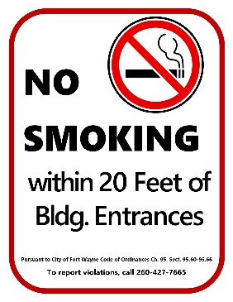
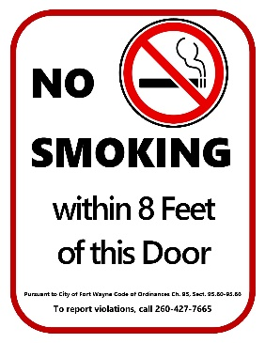
To be posted on the patio/deck side of doors leading to an enclosed patio or deck with no street-side access (not a public entrance to the building).
To be posted at all building entrances-- public, employees, deliveries, etc.

